Best SARIMAX order (v4): (2, 1, 0) (1, 0, 1, 7) CV MAPE: 15.971854292042869
deep28 -> val_loss=0.120265, window=28, bidir=False
deep21 -> val_loss=0.118881, window=21, bidir=False
bidir28 -> val_loss=0.118535, window=28, bidir=True

=== HOLDOUT (28d) RESULTS — v4 ensemble+ridge ===
MAE: 236.68
RMSE: 298.63
MAPE: 8.53%
Accuracy (1-MAPE): 91.47%
SARIMAX-only MAPE: 15.23% → ΔMAPE vs Hybrid: +6.70 pts
Calibration coefficients (ridge):
{'z1': np.float32(1.0262967), 'z2': np.float32(-1.6629965), 'z3': np.float32(-0.9205698), 'z1^2': np.float32(3.914474e-06), 'z2^2': np.float32(0.01502316), 'z3^2': np.float32(-0.015977373), 'z1*z2': np.float32(0.00018898422), 'z1*z3': np.float32(-0.0010111154), 'z2*z3': np.float32(-0.007918403), 'bias': np.float32(163.42982)}
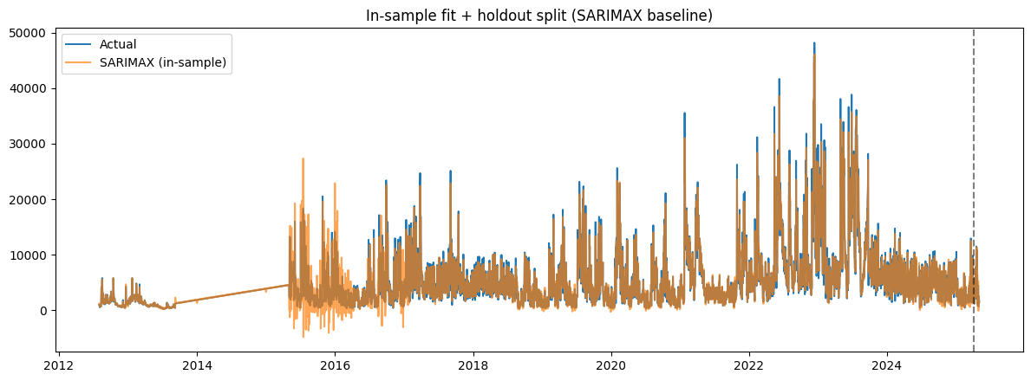
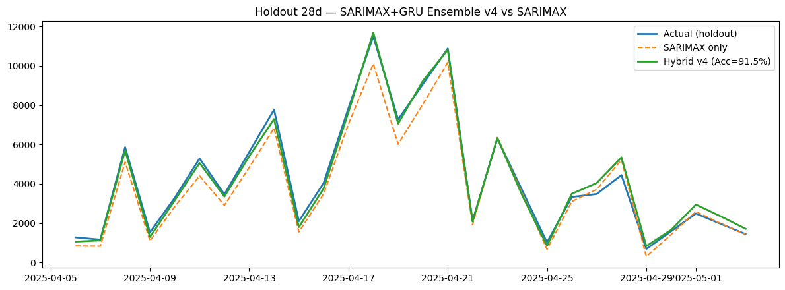
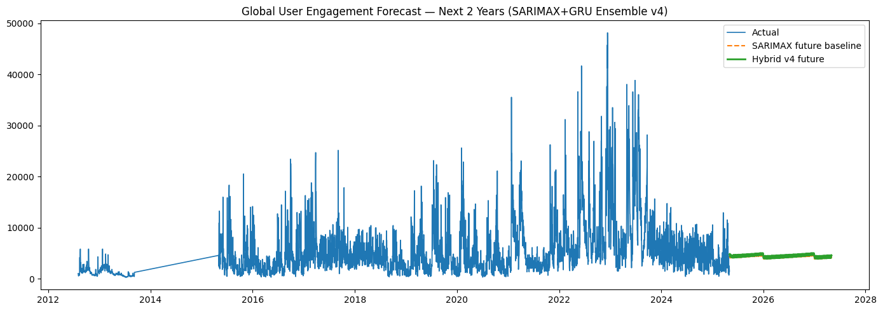

Artifacts: /content/hybrid_arima_gru_v4_artifacts
- 2year_forecast_sarimax_gru_v4.csv
- gru_v4_bidir28_win28.keras
- gru_v4_deep21_win21.keras
- gru_v4_deep28_win28.keras
- metrics_sarimax_gru_v4.json
- sarimax_order_v4.json
- sarimax_v4_model.pkl
- x_scaler_v4.npy
- y_scaler_v4.npy

Checkpoints: /content/arima_gru_v4_ckpts
- gru_v4_bidir28_win28.keras
- gru_v4_deep21_win21.keras
- gru_v4_deep28_win28.keras

